**Distance, Speed and Time**

**of the First Flight**

**Wright Brothers National Memorial**

|  |
| --- |
|  |

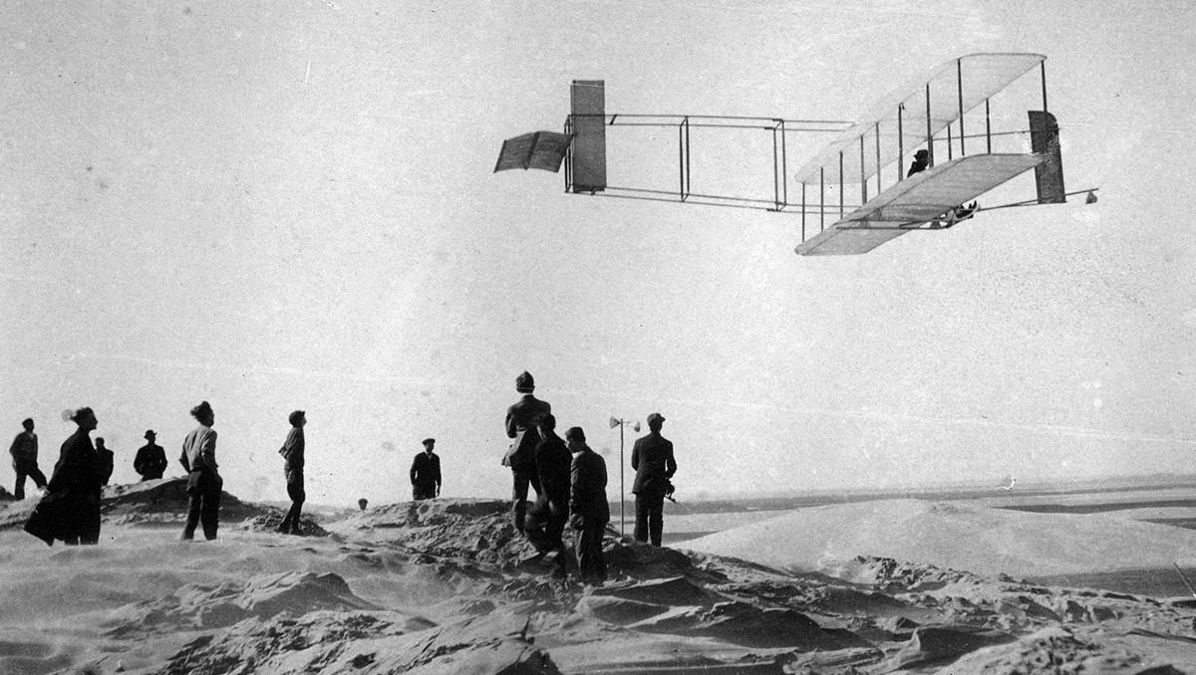

**Location:** On-Site

**Grade:** 8th grade

**Subject:** Mathematics

**Duration:** 90 minutes

**Key Vocabulary:** literal equations, rate, formula

**North Carolina State Standards:** NC.8.EE.7 Solve real-world and mathematical problems by writing and solving equations in one variable.

|  |
| --- |
|  |

**Objectives:** The student will be able to

**Materials:**

stop watches

measuring tapes

**Site Significance:** The Wright brothers’ realization of humanity’s age-old dream of powered, controlled, heavier-than-air flight at this site permanently transformed our perception of space and time, and changed the world forever.

1. solve the literal equation “Distance/Rate/Speed Formula” d=r * t for r (rate)
2. find the rates of the first 5 attempts at flight on December 14 and 17 of 1903
3. determine why the second test, piloted by Orville, was considered the “first flight”

**Essential Question:** How did the Wright brothers know they had successfully achieved the first flight?

**Method:** Students will physically simulate the flights by running and timing each trial, calculating the rate of speed, recording the data and comparing to the first five test flights.

**Background:** Wilbur manned the first powered test flight on December 14, 1903 achieving 112 feet in 4 seconds before crashing. The brothers attempted three more times on December 17, 1903 ( 120 feet/12 seconds, 175 feet/13 seconds, 200 feet/15 seconds respectively) before claiming success on the fourth attempt of that day which lasted 59 seconds and flew 852 feet. Wilbur was the pilot. The brothers did not use the dune to assist in their trials as gravity would have played a role negating the first man powered flight.

|  |
| --- |
|  |

**Suggested Procedure**

**Pre-Visit:** Teach the Distance/Rate/Speed Formula d = r * t

Solve the equations for r (rate) utilizing pre-taught literal equations skills/concept

**On-Site:**

1. With a partner, run the distance of the 5 first attempts at flight using the markers at the Wright Brothers National Memorial. For the first flight on December 14, 1903, measure the distance in relation to the first stone marker since there is no marker provided for that date.

2. Record results on table provided

3. Calculate your rates of speed for each of your trials

4. Calculate the rates of speed for the first 5 trials the Wright brothers performed based on the background information provided

5. Compare the difference

**Post-Visit:** Read the following article with a partner and discuss your thoughts.

<http://www.thewrightbrothers.org/fivefirstflights.html>

|  |
| --- |
|  |

**Concluding Question:**

Which, in your opinion, was the actual first flight and why?

**Extensions:**

1.) Sketch a picture of the arc of each flight on the same piece of paper. How do they compare?

2.) Research communications in 1903. What was it like? What were the challenges?

3.) What other math formulas were relevant to the first flight?

|  |
| --- |
|  |

**Additional Resources**

**Websites:** <http://www.thewrightbrothers.org/fivefirstflights.html>

**Books:** First Flight: The Wright Brothers and the Invention of the Airplane by Tom D. Crouch

|  |
| --- |
|  |